Task 3

1. Rank days by energy production
Concept: DENSE_RANK() window function.
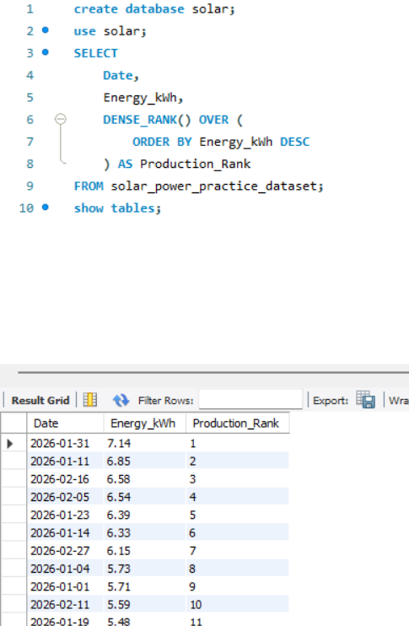

2. Calculate cumulative energy production

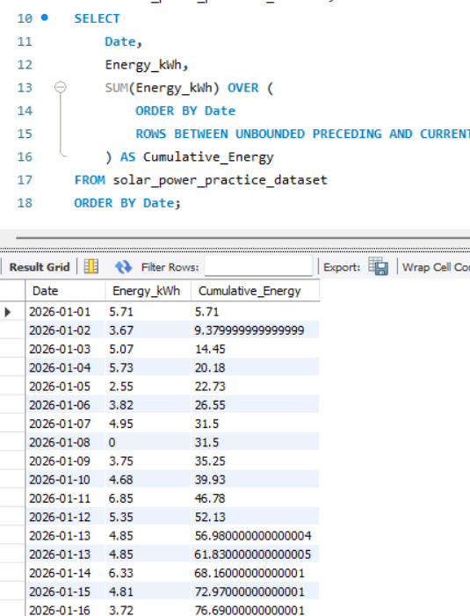

3. Compare average energy production by inverter status
Concept: Aggregation with GROUP BY and HAVING.
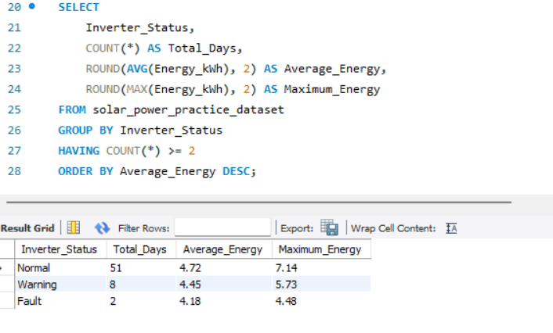

4. Find days with high sunlight but low energy production
Concept: Subquery and average-based filtering.
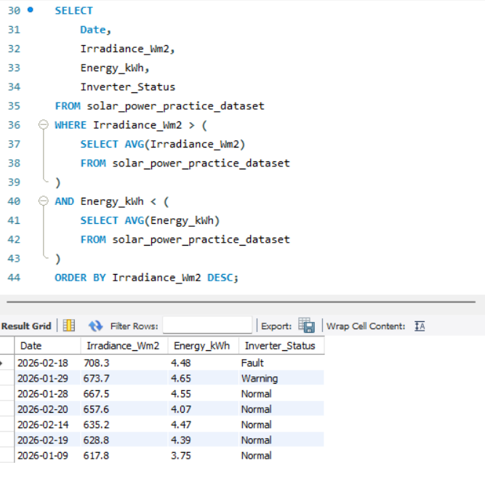

5. Calculate the daily temperature difference between the panel and the environment
Concept: Calculated columns and conditional filtering.
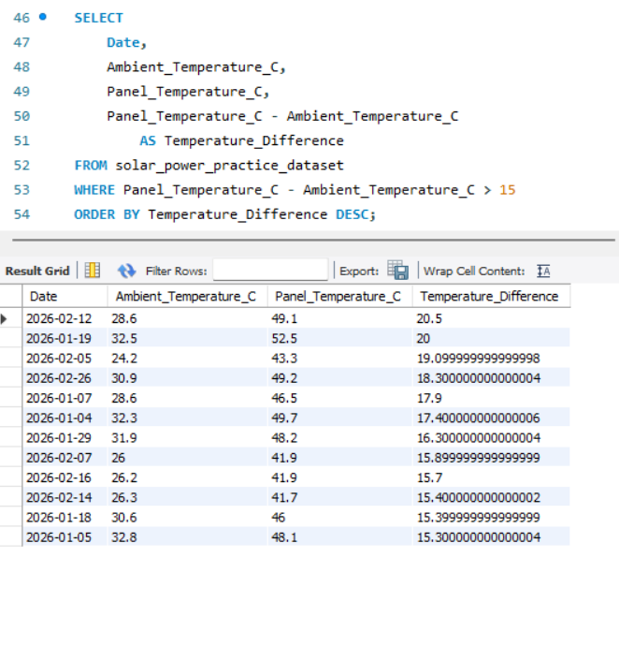

6. Compare rainy and non-rainy days
Concept: Conditional aggregation using CASE.
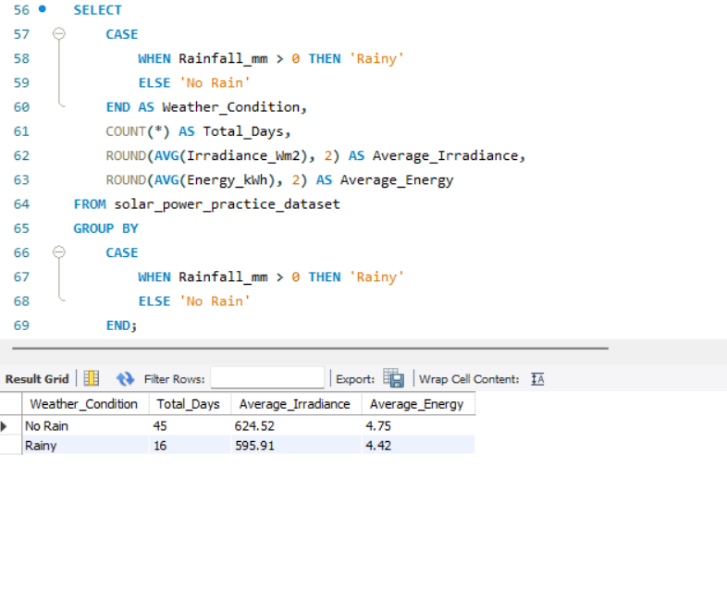

7. Detect unusually low energy production using a CTE
Concept: Common Table Expression (CTE) and statistical filtering.
